Predicate Logic- First Order Logic

* First-order logic is another way of knowledge representation in artificial intelligence. It is an extension to propositional logic.
* FOL is sufficiently expressive to represent the natural language statements in a concise way.
* First-order logic is also known as Predicate logic or First-order predicate logic. First-order logic is a powerful language that develops information about the objects in a more easy way and can also express the relationship between those objects.
* First-order logic (like natural language) does not only assume that the world contains facts like propositional logic but also assumes the following things in the world:
  + Objects: A, B, people, numbers, colors, wars, theories, squares, pits, wumpus, ......
  + Relations: It can be unary relation such as: red, round, is adjacent, or n-any relation such as: the sister of, brother of, has color, comes between
  + Function: Father of, best friend, third inning of, end of, ......
* As a natural language, first-order logic also has two main parts:
  + Syntax
  + Semantics

Basic Elements of First-order logic

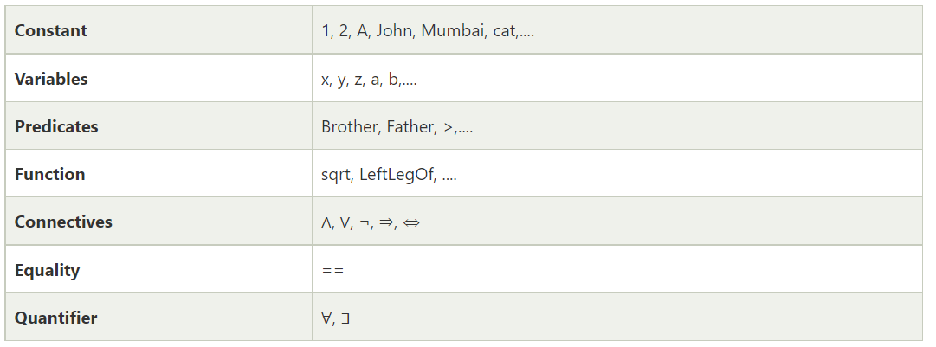

**Atomic sentences:**

* Atomic sentences are the most basic sentences of first-order logic. These sentences are formed from a predicate symbol followed by a parenthesis with a sequence of terms.
* We can represent atomic sentences as Predicate (term1, term2, ......, term n).

Example: Ravi and Ajay are brothers: => Brothers(Ravi, Ajay).

Chinky is a cat: => cat (Chinky).

Complex Sentences:

* Complex sentences are made by combining atomic sentences using connectives.

**First-order logic statements can be divided into two parts:**

* Subject: Subject is the main part of the statement.
* Predicate: A predicate can be defined as a relation, which binds two atoms together in a statement.

Consider the statement: "x is an integer.", it consists of two parts,

the first part x is the subject of the statement and

second part "is an integer," is known as a predicate.

Quantifiers in First-order logic:

* A quantifier is a language element which generates quantification, and quantification specifies the quantity of specimen in the universe of discourse.
* These are the symbols that permit to determine or identify the range and scope of the variable in the logical expression. There are two types of quantifier:
  1. **Universal Quantifier, (for all, everyone, everything)**
  2. **Existential quantifier, (for some, at least one).**
  3. The Universal quantifier is represented by a symbol ∀, which resembles an inverted A. Note: In universal quantifier we use implication "→".

Example:

**All man drink coffee.**

**∀x:man(x) → drink (x, coffee).**

It will be read as: There are all x where x is a man who drink coffee.

If x is a variable, then existential quantifier will be **∃x or ∃(x).** And it will be read as:

* There exists a 'x.'
* For some 'x.'
* For at least one 'x.'

Example:

Some boys are intelligent.

∃x: boys(x) ∧ intelligent(x)

**It will be read as: There are some x where x is a boy who is intelligent.**

**Points to remember:**

* The main connective for universal quantifier ∀ is implication →.
* The main connective for existential quantifier ∃ is and ∧.

**Properties of Quantifiers:**

* In universal quantifier, ∀x∀y is similar to ∀y∀x.
* In Existential quantifier, ∃x∃y is similar to ∃y∃x.
* ∃x∀y is not similar to ∀y∃x.

Some Examples of FOL using quantifier:

1. All birds fly.

∀x bird(x) →fly(x).

1. Every man respects his parents.

∀x man(x) → respects (x, parent).

respect(Ram, parents)

1. Some boys play cricket.

∃x boys(x) ^ play(x, cricket)

1. Not all students like both Mathematics and Science.

¬∀ (x) [ student(x) → like(x, Mathematics) ∧ like(x, Science)].

1. Lucy* is a professor
2. All professors are people.
3. John is the dean.
4. Deans are professors.
5. All professors consider the dean a friend or don’t know him.
6. Everyone is a friend of someone.
7. People only criticize people that are not their friends.
8. Lucy criticized John .

